Year 7

Student Name |  | Form
Half term | Super Curriculum Activities Completed  In this column write the activity that you have chosen for this half term | Signed Teacher  Get your teacher to sign here
Autumn 1
Autumn 2
Spring 1
Spring 2
Summer 1
Summer 2
Extra 1
Extra 2
Extra 3
The Copleston
Super Curriculum

Subjects | Read it… | Watch it… | Research it…
Art | Draw Paint Print like the Great Artists by Marion Deuchars’ | Landscape Artist of the Year (Sky One) | Research how to create the illusion of depth in 2D art work

D and T

Drama and Performing Arts

English

Food Technology and Textiles

French
Geography | Prisoners of Geography: Our World Explained in 12 Simple Maps by Tim Marshall | Seven Worlds One Planet with David Attenborough (BBC 2019) | Will the lights go out in the UK by 2100? Research how we produce our energy now and how we might in the future.

History
Subjects | Read it… | Watch it… | Research it…

IT

Maths

Music

PE

RE

Science

Spanish

Super Curriculum Information
Copleston super curricular activities are those that take your regular curriculum further. They take the subjects you study in the classroom beyond that which your teacher has taught you. These activities are normally in the form of extra reading but they can take other forms, like watching films or documentaries, researching articles online, visiting places or entering academic competitions.
Engaging in super curricular activities will help you develop a love of learning, improve your skills and widen your cultural experiences. In this booklet there are a range of activities for you to try. These are not exhaustive lists, but should get you started. We encourage you to share ideas and opportunities you come across with your teachers and peers so that, over time, the recommended activities in this booklet can grow.
In the future, employers or universities will be interested to hear about what additional curricular activities you have engaged in; they will be interested in what you have learnt and impressed by your efforts.
You will need to complete at least 1 activity per half term. You should try to do activities from as many different subjects as you can to increase the breath of your knowledge, with a maximum of 2 from any single subject. These will be discussed in your PSHEE lessons, where you will be able to share your ideas. For each completed activity you should prepare a short report.

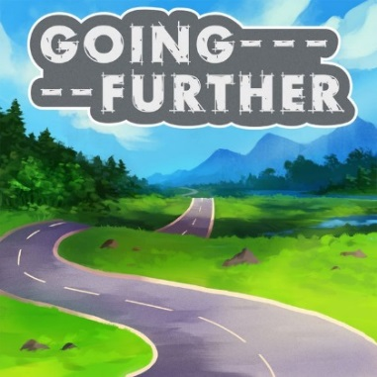

Recording your progress
In the table on the front cover you should keep track of all the activities you have completed. When you present your reports at the end of each half term, your teacher will sign the box to acknowledge that you have completed them. You will receive 10 reward points for each activity completed to a satisfactory standard, 20 rewards points for excellent pieces of work and Golden Tickets will be available for outstanding work, so go for it!
There is an expectation that you complete 6 activities over the year, one each half term. These are considerable pieces of work and will take you some time to finish. If you manage to complete 3 additional projects over the year, then you will get an additional reward!

