Read it… | ONLINE |  | BOOKS |  | OTHERS
 | TITLE | ☑ | TITLE | ☑ | TITLE | ☑
 | Sketchbook – eBook |  | The Contemporary Art Book |  | Art & Culture – Lonely Planet
 | Article | The Art Newspaper |  | The Art of Looking: How To Read Modern & Contemporary Art |  | BBC – Culture Art
 | Art | Art & Design | The Guardian |  | Living and Sustaining a Creative Life: Essays by 40 Working Artists |  | Art Monthly
 | ARTnews |  | Creative Block |  | Aesthetica Magazine
 | Entertainment & Arts – BBC News |  | Taking the Leap: Building a Career as a Visual Artist (the Insider’s Guide to Exhibiting and Selling Your Art) |  | Student Art Guide
 | Artdaily |  | History of Modern Art |  | Art in Tourism
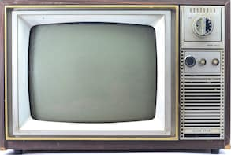  Watch it… | TELEVISION |  | FILM |  | YOUTUBE
 |  | ☑ |  | ☑ |  | ☑
 | The Joy of Painting |  | The Square |  | Proko
 | The Big Painting Challenge |  | Exit Through The Gift Shop: A Banksy Film |  | Draw with Jazza
 | Portrait Artist of The Year |  | Girl With A Pearl Earring |  | Emmy Kalia
 | The Great Pottery Throw Down |  | Phantom Thread |  | Fine Art Tips: Drawing Tutorials
Research it… |  |  | TRADITIONAL & CONTEMPORARY STYLES
 | Ways of Working | ☑ | Contextual influences | ☑ | Creativity and Expression | ☑
 | RSACC – Creative Ways of Working |  | Art in the 21st century |  | Psychology Today: The Art of Creativity
 | Art Styles and Movements |  | History of Art |  | Conceptual Art
Listen to it… | PODCASTS
 |  |  |  |  |  | ☑
 | The Lonely Palette
 | Tate Modern – Podcasts

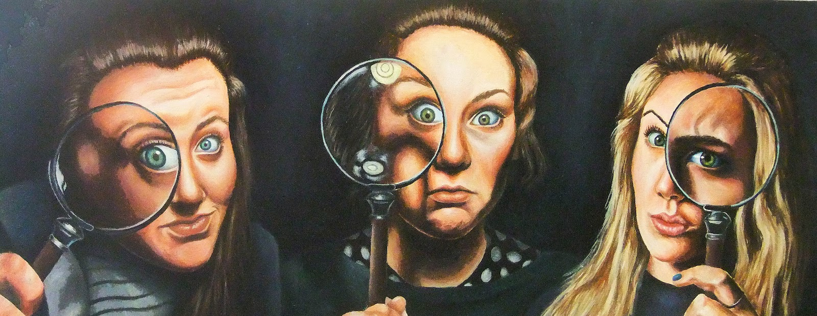
COURSE ORGANISATION
A Level Art is a 2 year course whereby you will complete 2 internally set components, and 1 externally set component. Each component is designed to allow you to explore your own conceptual and practical areas of interest.

To be successful in A Level Art it is imperative that in depth and critical investigations are completed in your sketchbook, which collate to formulate a planned, and refined final outcome.

By regularly completing the tasks in this booklet (recommended one per half term), you will likely find yourself more inspired, and able to think outside of the box.

A Level Art
ART SUPER CURRICULUM ACTIVITIES
Art Super Curricular Activities are those that take your regular curriculum further. They take the subjects you study in the classroom beyond that which your teacher has taught you. These activities are normally in the form of extra reading but they can take many other forms, like watching films or documentaries, researching articles online, listening to podcasts, visiting places or entering competitions.

Engaging in Art super curricular activities will help you develop a real passion
for the subject. It takes you from being a student who learns how to get a qualification in Art, to a true Art student, who goes above and beyond.

In this booklet, there are a range of activities, these are by no means exhaustive lists, but should get you started. We encourage you to share ideas and opportunities you come across with your teachers and peers so that, over time, the recommended activities in this booklet can grow.

In the future, employers or universities will be interested to hear about what additional curricular activities you have engaged in; they will be interested in what you have learnt and impressed by your efforts. Part of a University personal statement asks you to talk about how you have demonstrated your passion for your subject, this booklet is full of potential answers to that question.

We suggest you complete at least 1 activity per half term. You should write up what you find, or what you learn, in some form and share it with your teachers and fellow students.

